# Report of game Hero Dungeon

The game Hero Dungeon is in style of dungeon crawler. The goal is to defeat all the enemies and retrieve golden key. In this game there are couple of scenes. The first scene is the Main menu. In this scene there are three options. First one is Play. This starts the game and switches current scene to Story. Next option is Info. Here you can see credits of the game and controls. The last option enables user to leave the game.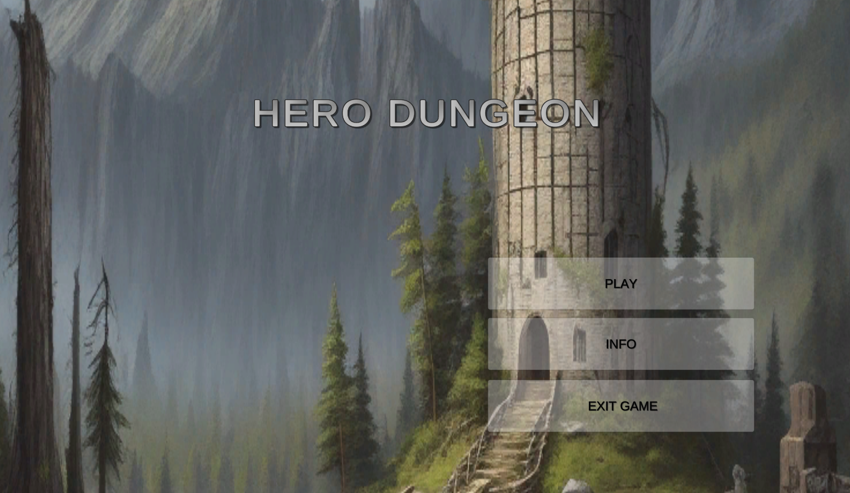

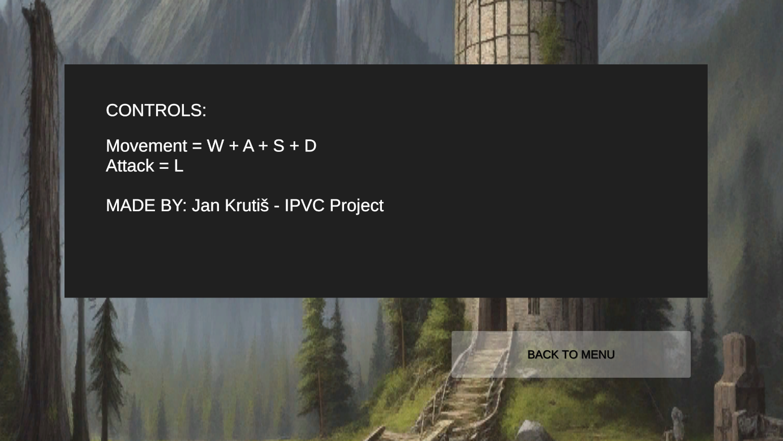

If user selects option Play, game starts by telling story with couple of slides. Each slide has next button to give player time to read its contents. The last slide wishes player good luck and if he clicks on next, outside scene is loaded. 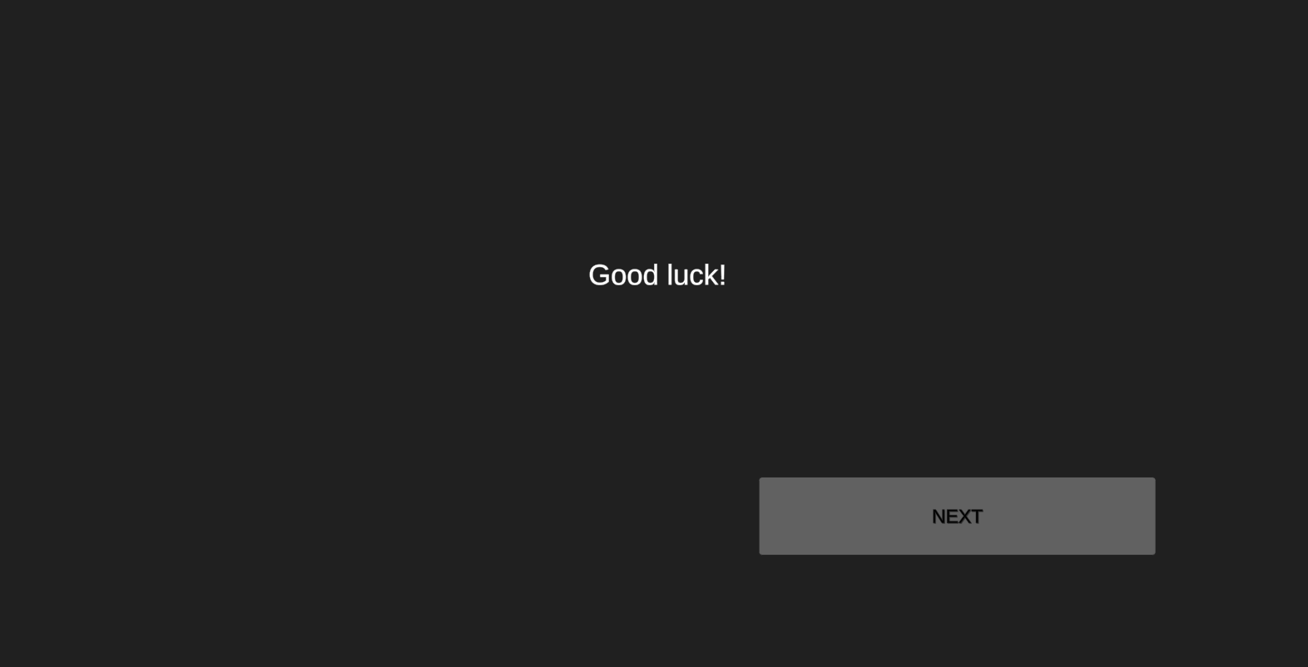

In the outside scene, the goal is to enter dungeon. There are few new elements. On the top right there is goal, that the player has to complete. Bellow there is players health bar. The controls are WASD for movement and L for attack. Whole game is played in top-down look and the camera follows player. Style of the game is mostly Low-pollygon. When player walks through the gate, dungeon scene will be loaded. 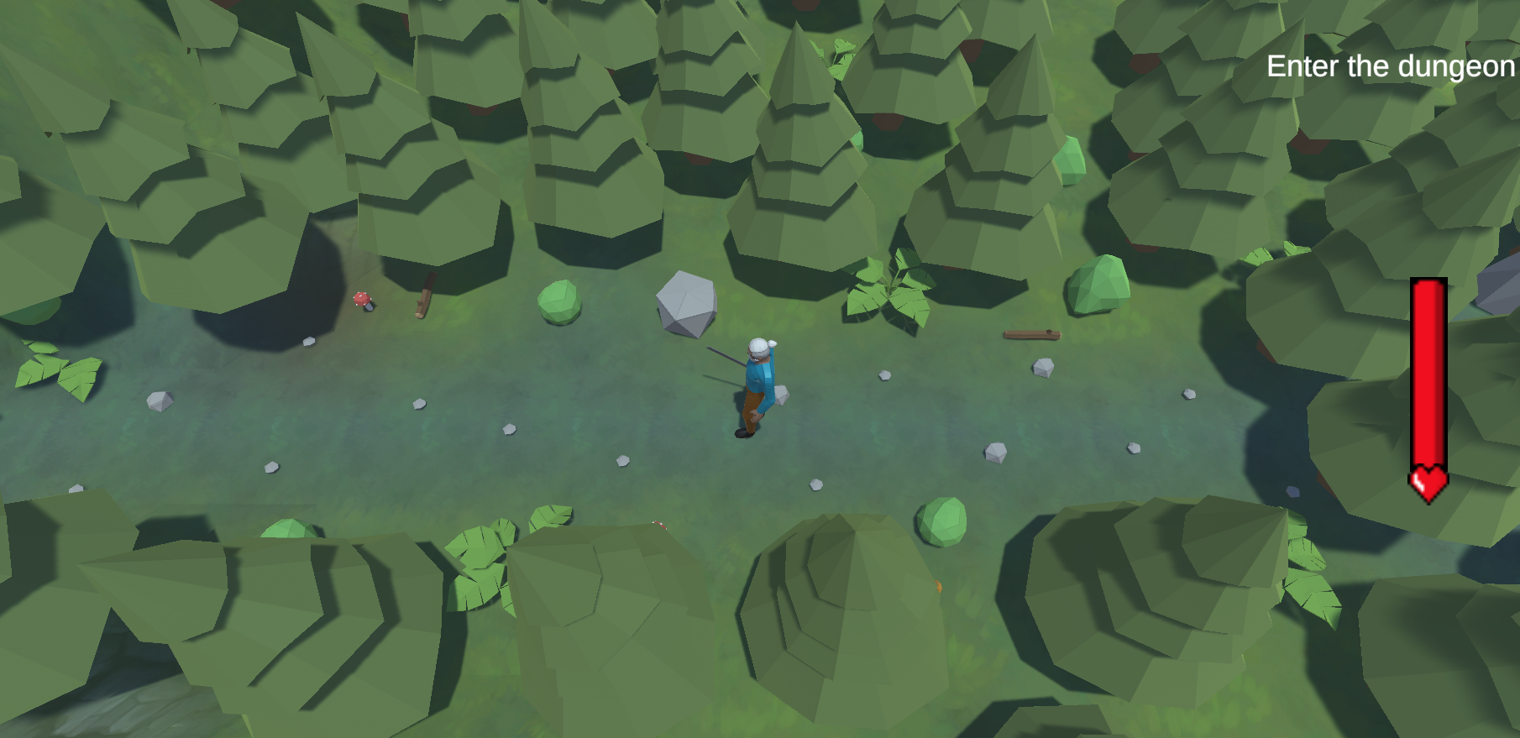

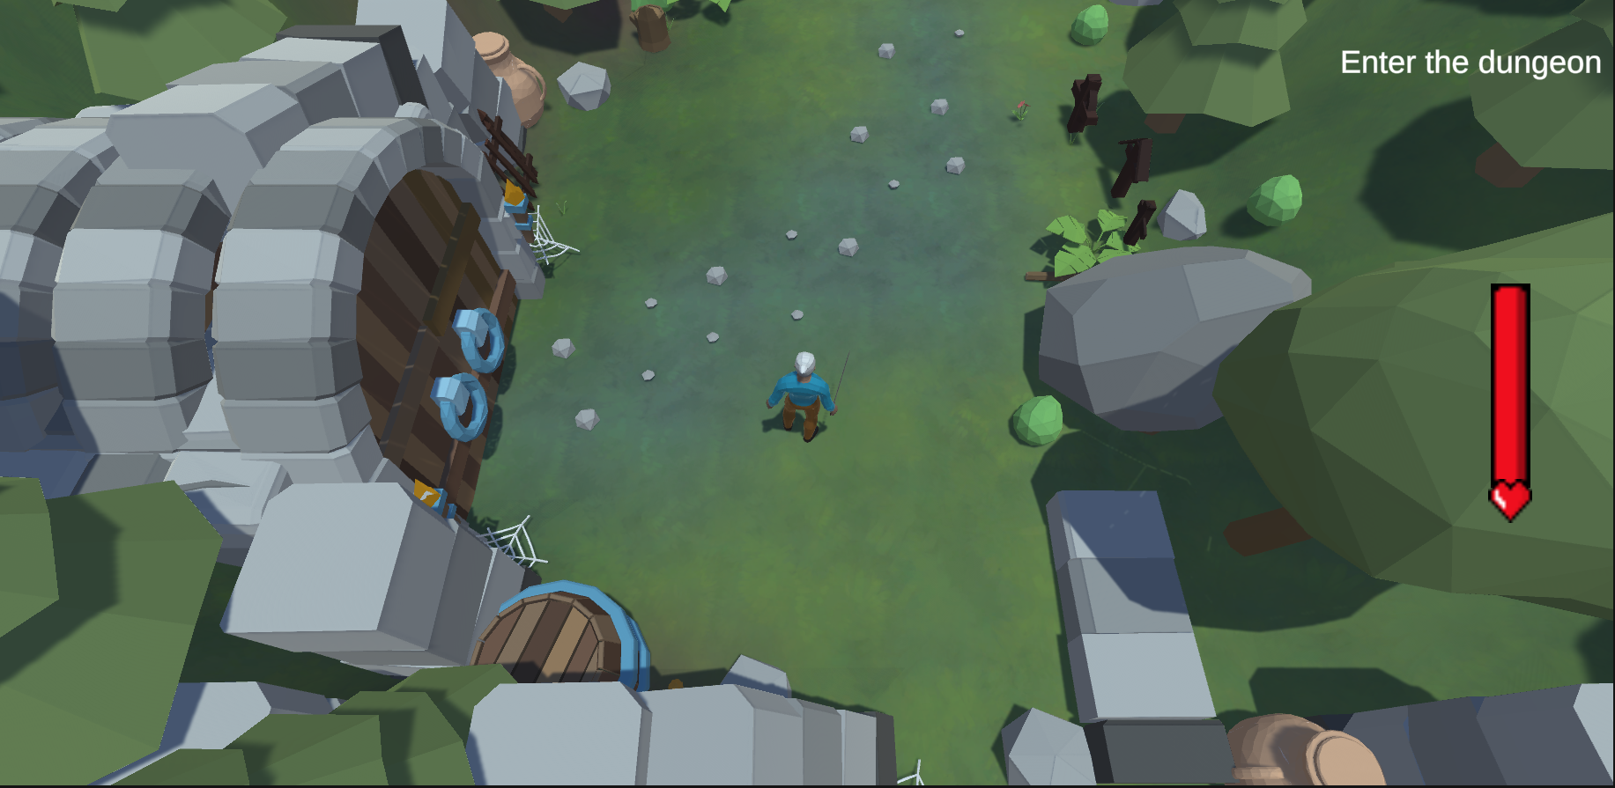

Main scene of the game is dungeon level. Here the main goal is to defeat boss, and retrive key. There are 3 types of enemies on this level. Bronze ones are the weakest, then there are silver skeletons, and final boss is golden skeleton. Each level of enemy is distinguished by amount of health their speed, and range of detection. 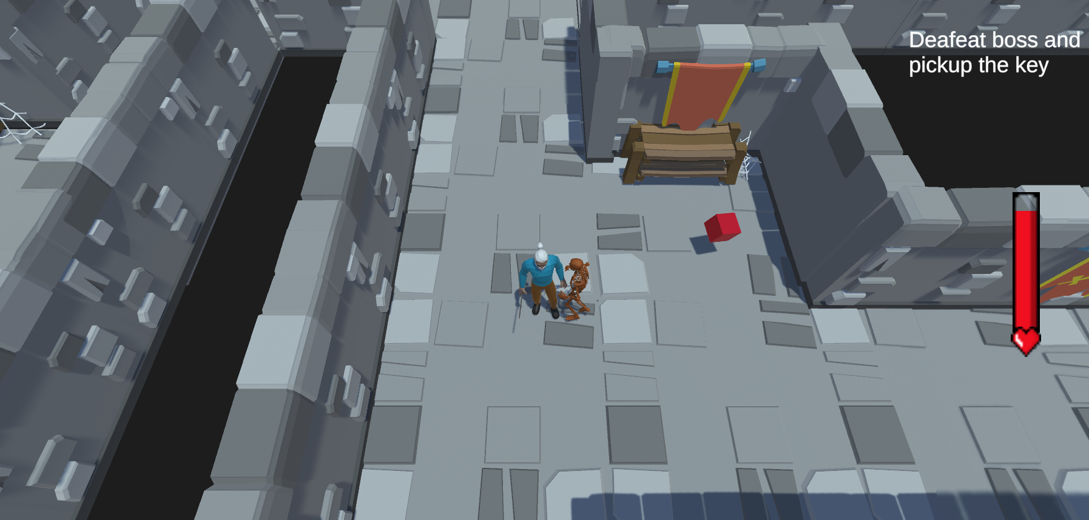

If the players health reaches 0 the scene is set to death, and player has to repeat the whole game.

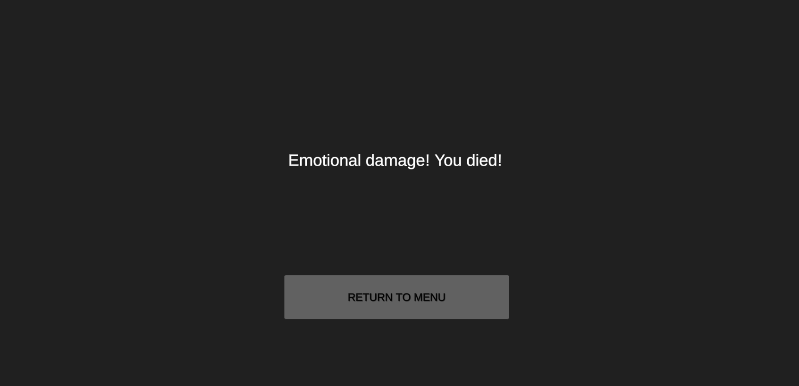

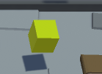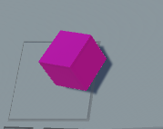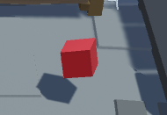To help the player to acomplish the goal, there are 3 types of health objects that player can pickup and heal himself. Player has 500 health. The weakest heal is the red cube. This adds only 100 health to the player. Next one is yellow cube, which adds 200 health. Finally the pink cube adds 350 health.

When the player goes through the dungeon, he has to find treasure room with golden skeleton.

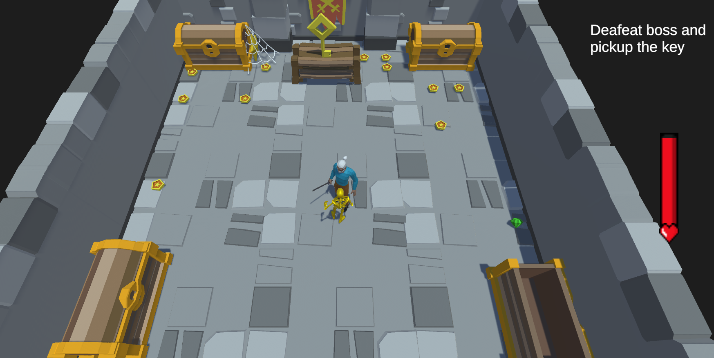

After the skeleton is defeated, he can pisckup the key. Key is picked up by approaching the bench with key. Boss skeleton must be defeated before pickup. After aproach the win scene is loaded. This is the finish of the game, and the button in this scene loads main menu.

